**IO1.B – Guideline Final Assessment**

The MathE Portal provides the lecturers involved in the project with the possibility to create Final Assessments for their students.

Both lecturers and students need to be registered in the portal in order:

* To create the final assessments (the lecturers)
* To participate in the final assessments (the students)

The process to create a final assessment is the following one:

1. The lecturer, in his Reserved Area, should click on “Create New Final Assessment

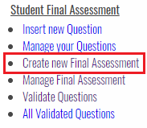

1. The lecturer feels in the general information related to the Final Assessment:

* Title of the Final Assessment
* Description
* Date and Time: these refer to the time zone of the University of the lecturer
* Duration

This information will be visible for the students when registering to the Final Assessment

1. The lecturer should add the questions to the exam choosing from:

* His own questions (if he/she created them)
* The questions available in the MathE database

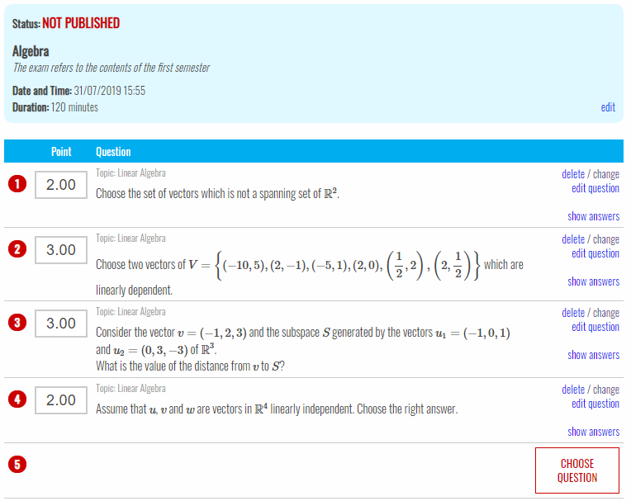

Each question can be:

* Deleted
* Changed: replacing it with another one
* Edited: the edit will not affect the question on the MathE database, but only the one for the specific final assessment

Points assigned to each question

The exam is not published and therefore it is not visible for the students. In order to make it visible it is necessary to click on Edit and modify the status.

|  |
| --- |
| **Timing**  The lecturer:  - must publish (therefore, make visible for the students) the exam at least 1 day before the exam itself  - can modify the exam (date, time, questions) unless the exam is already started |

1. The student, by clicking on the menu on Final Assessment”, access to the list of Final Assessments available in the institution he/she belongs to.

In order to participate in the final assessment the student must:

* Choose in the Menu “Final Assessment”
* Click on the button “Ask to participate”

|  |
| --- |
| **Timing**  The student can “ask to participate” in the exam until the day before the exam itself. |

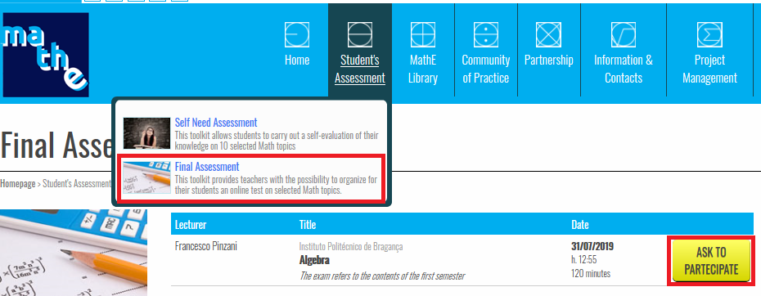

1. The lecturer, by clicking on “Participants” has the possibility to accept or reject the students. This possibility is available until the minute before the assessment starts.

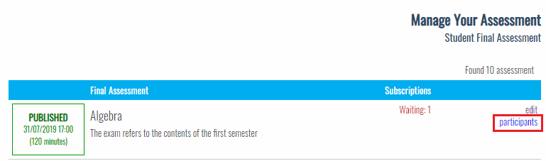

1. The student visualizes the information in the list of assessments.

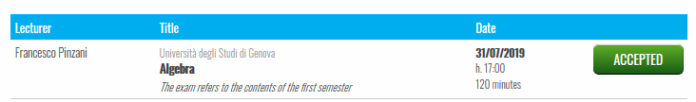

1. The day of the final assessment the student visualizes the time when the assessment is going to start

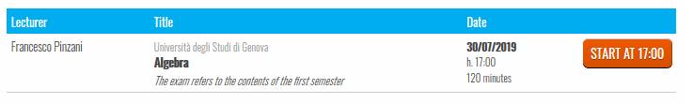

1. The minute that the assessment is planned, the student can start it by clicking on “Start Assessment”

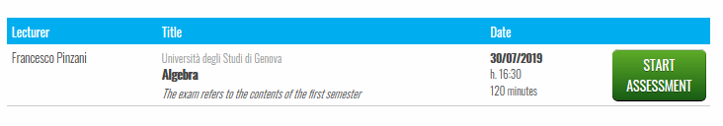

1. The lecturer cannot modify the contents of the assessment after it is started.
2. Answering the questions, the students has 3 options:

* Choose the answer he/she thinks is the correct one
* Skip the question
* Choose “I do not know”

1. Once the student has chosen an answer to all questions, he/she has the possibility to change the answer to all of them and it is compulsory for him/her to choose one.